Olusola Olaniyi

Task 3.8 Performing Subqueries

Step 1.

Step 2.

SELECT

D.country,

COUNT(DISTINCT A.customer_id) AS all_customer_count,

COUNT(top_5_customers) AS top_customer_count

FROM customer A

INNER JOIN address B ON A.address_id = B.address_id

INNER JOIN city C ON B.city_id = C.city_id

INNER JOIN country D ON C.country_id = D.country_id

LEFT JOIN

(SELECT

A.customer_id,

A.first_name,

A.last_name,

D.country,

C.city,

SUM(E.amount) AS total_amount_paid

FROM customer A

INNER JOIN address B ON A.address_id = B.address_id

INNER JOIN city C ON B.city_id = C.city_id

INNER JOIN country D ON C.country_id = D.country_id

INNER JOIN payment E ON A.customer_id = E.customer_id

WHERE C.city IN ('Aurora', 'Acua', 'Citrus Heights', 'Iwaki', 'Ambacur', 'Shanwei', 'So Leopoldo',

'Teboksary', 'Tianjin', 'Cianjur')

GROUP BY A.customer_id,

A.First_name,

A.last_name,

C.city,

D.country

ORDER BY total_amount_paid DESC

LIMIT 5) top_5_customers ON A.customer_id = top_5_customers.customer_id

GROUP BY D.country

ORDER BY all_customer_count DESC

LIMIT 5;

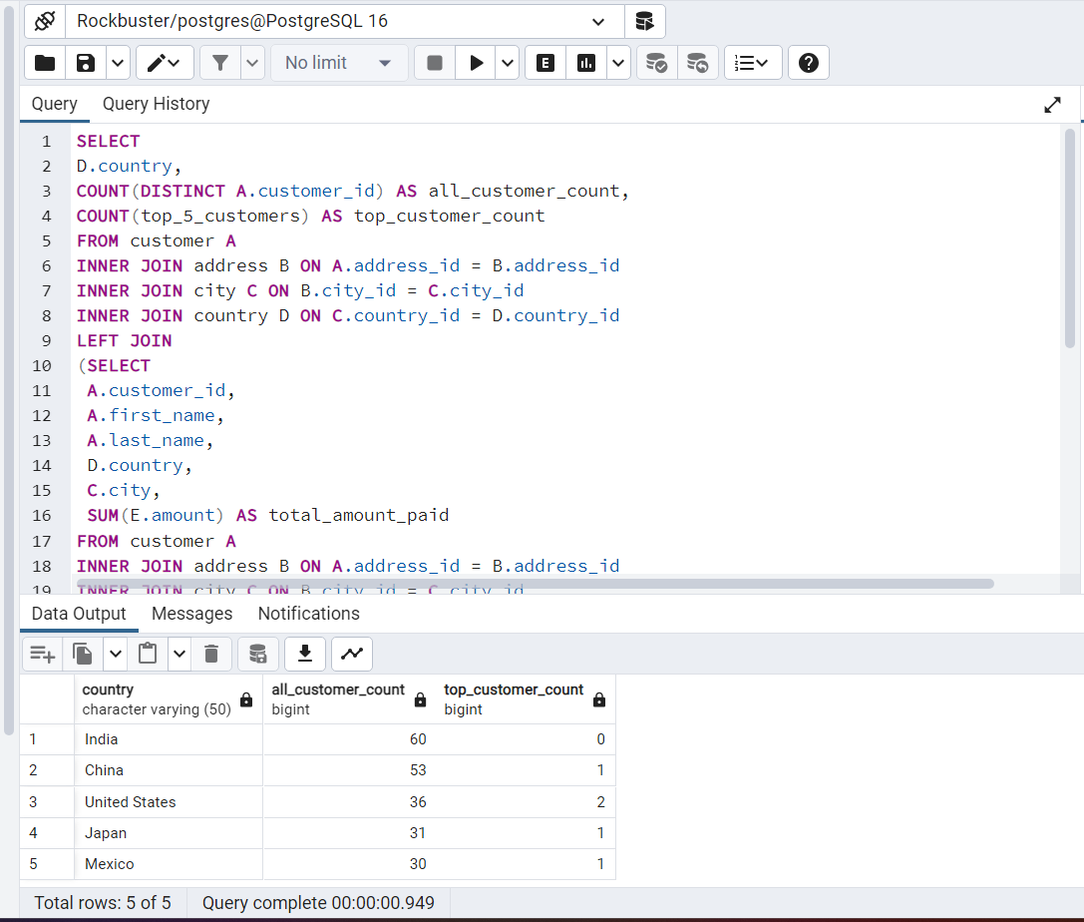

Step 3.

Well, I think step 1 and 2 should have been done without using subqueries because we've been able to identify top 10 cities in the last task 3.7. Though subqueries are very useful in complex queries with multiple joins. I think subqueries are very useful where a query depends on the results of another query. Using only JOINS could have been less complex.